Steps to Create an Account on Netlify and Upload a Project
1. Open Netlify Website
- Open any web browser.
- Go to the official Netlify website.

- Click on the “Sign up” button on the homepage.

2. Create a Netlify Account
- Choose a sign-up method:
  - Sign up with GitHub
  - Sign up with GitLab
  - Sign up with Email
- If using email:
  - Enter your email address.
  - Create a password.
  - Verify your email by clicking the verification link sent to your inbox.
- After verification, you will be redirected to the Netlify dashboard.

3. Login to Netlify Dashboard
- Enter your registered email and password.
- Successfully log in to access the Netlify dashboard.
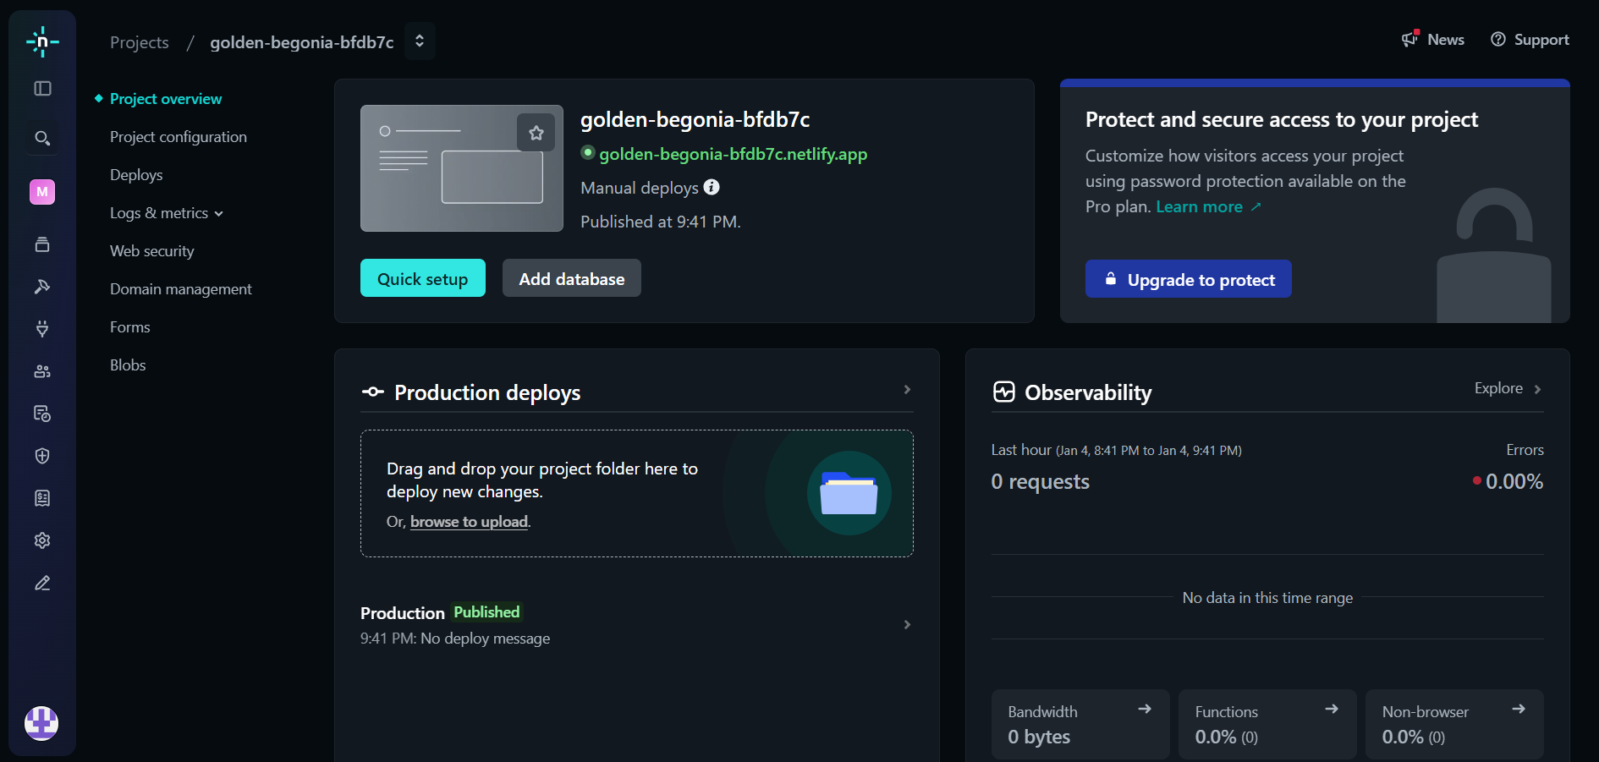

4. Prepare the Project File
- Create a simple project folder on your computer.
- The folder should contain:
  - An index.html file (mandatory for static sites).
  - Optional files like CSS or images.
- Ensure all project files are inside one single folder.
- In the Netlify dashboard, click on “Add new site”.
5. Upload Project Using Drag and Drop
- Select “Deploy manually” or “Deploy without Git”.
- Drag and drop your project folder into the given upload area.
- Netlify will automatically start deploying your project.

6. Project Deployment
- Wait for a few seconds while Netlify processes the files.
- Once deployment is complete, Netlify will generate a live website link.
- The site status will show “Published”.
7. Access the Live Project
- Click on the generated Netlify URL.
- Your uploaded project will open in the browser.
- The project is now successfully hosted online.
